Women & Retirement
  - FALL FOCUS GROUP

who

Women who are in, approaching, or re-thinking retirement. Women who are curious about how to renew and re-vision this next chapter of life.

why

To talk about your experiences with others and to give your opinion on potential programs. We’ll explore satisfaction, meaning, concerns, and creativity at this time of life.

when

Nov. 1, 2019 from 10:00 to 12:00

where

Panera Community Room

4519 N. High Street, Clintonville

RSVP by Oct. 28, 2019 macaliv@cs.com  Virginia Macali, JD, MS, founded High Point Transitions to support people moving through transitions in smart, aware, and balanced ways. She is a retirement transition consultant and integral life coach. She is a co-founder of Aging with Intention and writes a blog that explores the next chapter of life. | 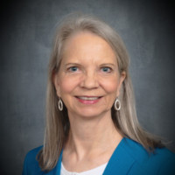

High Point Transitions, LLC

Virginia Macali, JD, MS

Retirement Coaching for Professionals | Next Chapter Explorations

www.virginiamacali.com 614.296.6287

